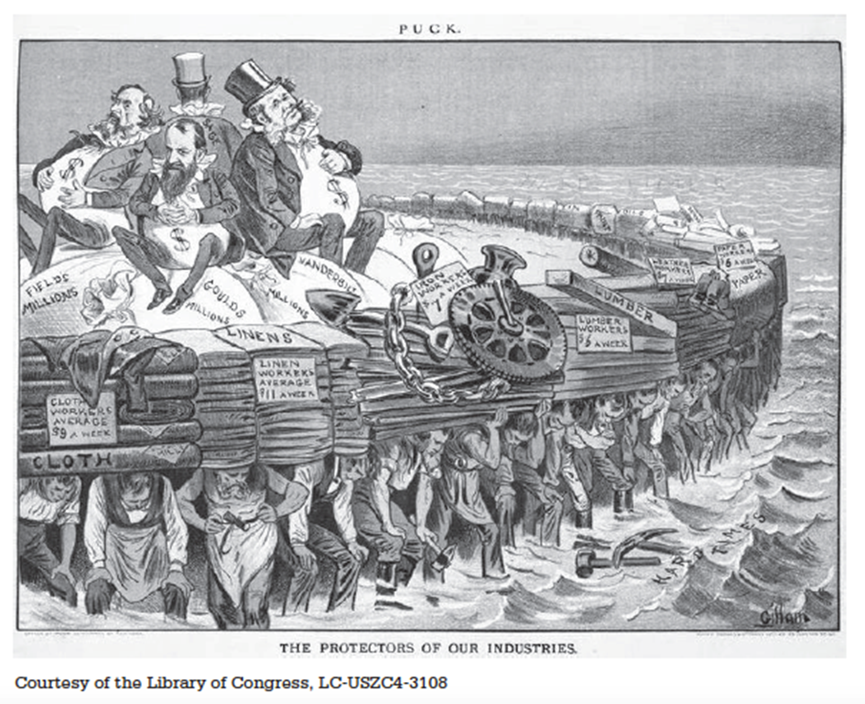

Using the 1883 image above, answer a, b, and c.
- Briefly explain the point of view about the economy expressed by the artist.
- Briefly explain ONE development in the period 1865 to 1910 that could be used to support the point of view expressed by the artist.
- Briefly explain ONE development in the period 1865 to 1910 that could be used to challenge the point of view expressed by the artist.

