Directions:
The following question requires you to construct a coherent essay that integrates your interpretation of Documents A-J and your knowledge of the period referred to in the question. High scores will be earned only by essays that both cite key pieces of evidence from the documents and draw on outside knowledge of the period.
Analyze the ways in which technology, government policy, and economic conditions changed American agriculture in the period 1865-1900.
In your answer be sure to evaluate farmers' responses to these changes.
Document A
Agricultural Prices in Dollars per Unit, 1865 - 1900
Source: Historical Statistics of the United States
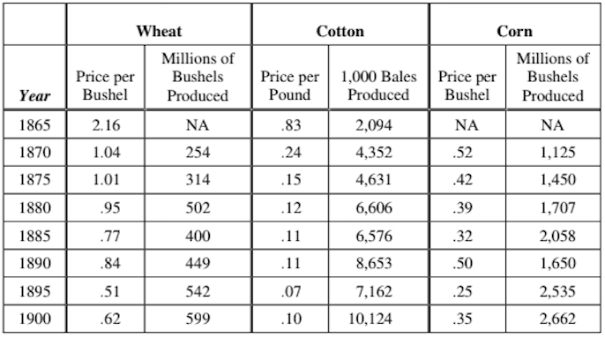
Document B
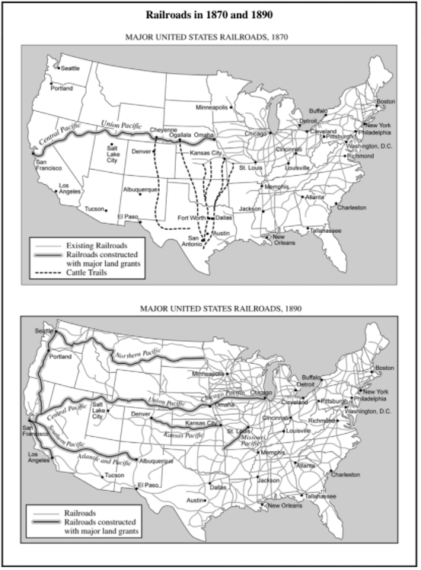

Document C

Source: Prairie Farmer, July 14, 1877.
Our western brothers have accomplished one great good by their war upon the railroads. Some time ago they carried a law through the Illinois legislature, which provides for the limiting of freight rates by a board of officials appointed for this purpose. The railroads, of course, opposed this measure, and it was carried to the United States Supreme Court to test its constitutionality, resulting in a complete victory for the Patrons. Illinois is the only state in the country to have such laws.
Document D
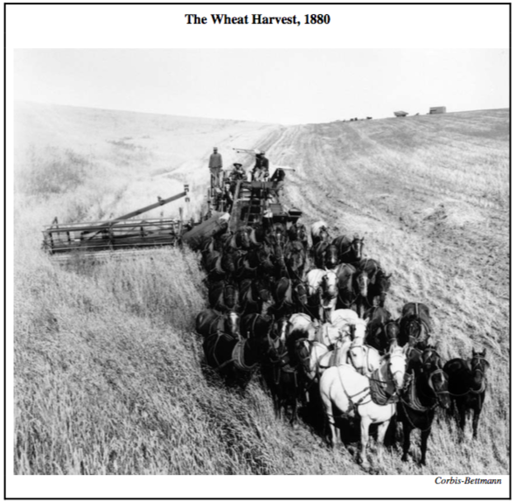
Document E
Source: A contract in North Carolina, 1882
To every one applying to rent land upon shares, the following conditions must be read, and agreed to...
The sale of every cropper's part of the cotton to be made by me when and where I choose to sell, and after deducting all they owe me and all sums that I may be responsible for on their accounts, to pay them their half of the net proceeds.
Document F
Source: Harper's New Monthly Magazine, 1884
An establishment in Chicago which combines the operations of "shipping" and of "canning" beef has a slaughtering capacity of 400,000 head annually. When we add to this the requirements of other similar although smaller concerns, and the larger number shipped eastward on the hoof, we have a grand total of not far from 2,500,000 head marketed in the city of Chicago alone... Whence does it come? Let the five great trunk lines which have their termini on the borders of Lake Michigan answer. Like the outstretched fingers of a hand, they meet in the central palm, Chicago. All from the West, but from the extreme northern and southern portions, Texas representing the latter, and the utmost limits of Montana the former. Ten thousand miles of rail at least are occupied in th[is] transit...
Document G
Source: Speech by Mary Elizabeth Lease, 1892
Money rules...The parties lie to us and the political speakers mislead us. We were told two years ago to go to work and raise a big crop that was all we needed. We wen to work and plowed and planted; the rains fell, the sun shone, nature smiled, and we raised the big crop that they told us to; and what came of it? Eight-cent corn, ten-cent oats, two-cent beef, and no price at all for butter and eggs—that's what came of it.
Then the politicians said we suffered from overproduction. Overproduction, when 10,000 little children, so statistics tell us, starve to death every year in the United States.
Document H
Source: In Kansas, Susan Orcutt to Lorenzo D. Lewelling, June 29, 1894.
I take my Pen In hand to let you know that we are Starving to death It is Pretty hard to do without any thing to eat in this God for saken country we would have had Plenty to Eat if the hail hadent cut our rye down and ruined our corn and Potatoes I had the Prettiest Garden that you Ever seen and the hail ruined It and I have nothing to look at my Husband went a way to find work and came home last night and told me that we would have to Starve he has bin in ten countys and did not Get no work It is Pretty hard for a woman to do with out any thing to Eat
Document I
Source: R. W. McAdams, Oklahoma Magazine, 1894
Many of the country's most profound students of the Indian question — men and women who have made the race and its relation to the nation a life study — have become converts to the policy of individualism and severalty. The citizenship question aside, the folly and injustice of reserving many millions of acres of arable land as a wilderness used only as a camping ground for a few thousand lazy, squalid governmental paupers is palpable. If the Indians must be fed and herded like a dumb brute, it should be done with smaller enclosures and not so senselessly at the expense of the American homesteader.
Document J
Source: Excerpts from a speech by William Jennings Bryan, July 1896
You come to us and tell us that the great cities are in favor of the fold standard. I tell you that the great cities rest upon these broad and fertile prairies. Burn down your cities and leave our farms, and your cities will spring up again as if by magic. But destroy our farms and the grass will grow in the streets of every city in the country.
If they dare to come out in the open field and defend the gold standard as a good thing, we shall fight them to the uttermost, having behind us the producing masses of the nation and the world. Having behind us the commercial interests and the laboring interests and all the toiling masses, we shall answer their demands for a gold standard by saying to them, you shall not press down upon the brow of labor this crown of thorns. you shall not crucify mankind upon a cross of gold.

