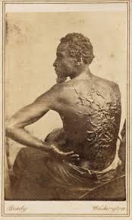

“The Scourged Back” 1863 Photographed during Civil War by Mr. William McPherson