AP United States History
2020 Exam SAMPLE DBQ
(Adapted from past AP U.S. History exam DBQs)

Allotted time: 45 minutes (plus 5 minutes to submit)

Directions: This question is based on the five accompanying documents. The documents have been edited for the purpose of this exercise.

In your response you should do the following.
- Respond to the prompt with a historically defensible thesis or claim that establishes a line of reasoning.
- Describe a broader historical context relevant to the prompt.
- Support an argument in response to the prompt using at least four documents.
- Use at least two additional pieces of specific historical evidence (beyond that found in the documents) relevant to an argument about the prompt.
- For at least two documents, explain how or why the document’s point of view, purpose, historical situation, and/or audience is relevant to an argument.
- Use evidence to corroborate, qualify, or modify an argument that addresses the prompt.

Evaluate the relative importance of the causes of cultural change in the United States in the period from 1914 to 1945.

Document 1

Source: Charles S. Johnson, reporting on interviews with African American migrants to Chicago, 1917.

Mr. Hunter . . . from Meridian, Miss. . . . came to Chicago in December. Wife in April, mother and children in July. . . . Mrs. Hunter, his mother, had occasion to go to Birmingham. There the people were leaving in large numbers for the North, mostly men. She asked why. They said, higher wages. . . . She herself could not believe. [She] went home and told her son . . . and urged him to go and see for himself. He left in December, in 3 weeks he wrote home. “Everything is just like they say, if not better.” Then he sent money for his wife in April. . . . Meanwhile excitement at home was waxing warm. Her neighbor’s daughter ventured North. She had been receiving at home $2.00 per week. Worked in the Stockyards at $2.00 per day.

Document 2

Source: Closing the Gate, Chicago Tribune, 1919.

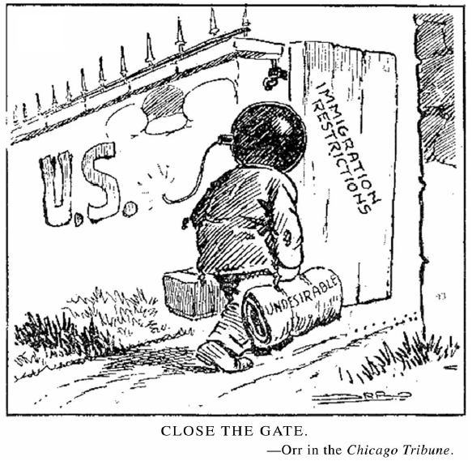

Document 3

Source: Fannie Hurst, New York Times, 1923.
The place of the woman of intelligence is not inevitably in the kitchen worrying about pot and pan trifles, not at the front door every evening waiting tremulously [nervously] for the step of her John and fearful lest the roast be . . . overdone. Her place is where she can give the most service and get the most out of life . . . .

Document 4

Source: John Dewey, The Public and Its Problems, 1927.
The present era of “prosperity” may not be enduring. But the movie, radio, cheap reading and motor car with all they stand for have come to stay. That they did not originate in deliberate desire to divert attention from political interests does not lessen their effectiveness in that direction. The political elements in the constitution of the human being, those having to do with citizenship, are crowded to one side. . . . Let there be introduced the topic of the mechanism and accomplishment of various makes of motor cars or the respective merits of actresses, and the dialogue goes on at a lively pace.

Document 5

Source: President Franklin Roosevelt, address at the opening of the Museum of Modern Art, 1939.

The arts that ennoble and refine life flourish only in the atmosphere of peace. And in this hour of dedication we are glad again to bear witness before all the world to our faith in the sanctity of free institutions. For we know that only where men are free can the arts flourish and the civilization of national culture reach full flower….

Art in America has always belonged to the people…The great Treasury projects, through which our public buildings are being decorated, are an excellent example of the continuity of this tradition. The Federal Art Project of the Works Progress Administration is a practical relief project which also emphasizes the best tradition of the democratic spirit. The W.P.A. artist, in rendering his own impression of things, speaks also for the spirit of his fellow countrymen everywhere. I think the W.P.A. artist exemplifies with great force the essential place which the arts have in a democratic society such as ours.

